**TryHackMe – Mr Robot CTF**

**Victim**: 10.10.125.184

**Kali**: 10.8.180.190

**N****map**

**Viewing Scan**



When I looked at the URL I noticed the ending would change to fit the command. I then thought about adding a custom command “LS” to try and list contents. However I got some useful information.

**WPScan**



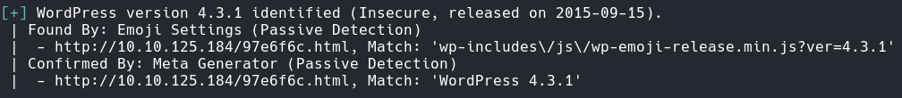

**HTTPie**

There was this hash value and there was a dictionary downloaded.

**FFUF**

Nothing was found.

**Gobuster**





Nothing really of interest has been found.

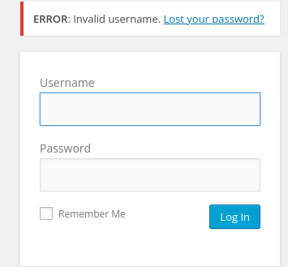After looking at the login page for a bit, I started testing some usernames and passwords. I realised that information about the username was given.

**Hydra**

The reason why the password test was used because I want to discover the valid username. This is only possible because of the ERROR message that is displayed telling us that either the username or password is incorrect.

It’s a post request because I looked at burp suit and saw a post request to submit the username & password. The last part of the command shows success based on the error message produced.

Password discovered was ER28-0652. (forget to get a screenshot).

Exploitation

In the dashboard I went to appearance, then editor. Next, I went to archives.

I then replaced the existing PHP code with my own reverse shell from pen test monkey.

Setup netcat, this will allow you to connect.

Go to the site above.

Now I am in.

**Upgrade Shell**

LinPEAS

I then downloaded linPEAS onto the victim machine.

I was able to obtain a hash for the next account (lateral movement).

**Crackstation**

I was able to crack the hash (abcdefghijklmnopqrstuvwxyz).

|  |
| --- |
|  |

**Flag 2**

I will try to use the kernel exploit (dirtycow).

It didn’t work.

**Find SUID Binaries**

Nmap is an interesting one.

I read that you can spawn a shell using nmap, once you have entered interactive mode.

Bash spawning didn’t work.

Shell spawning gave me root.

**Flag 3**